









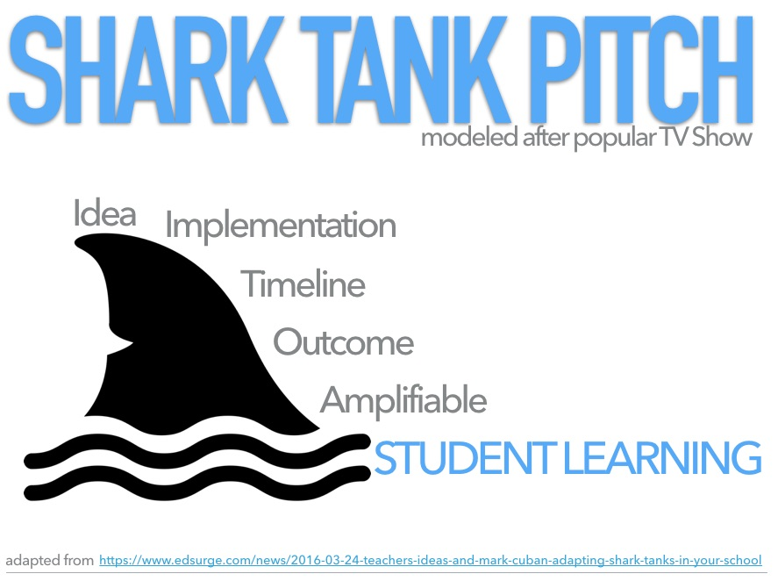

**Objective:** You must give a sales pitch to a group of wealthy investors who could help make your product a success. You must sell them on your product using a balance of ethos, pathos, and logos. If you convince them, they will give you a significant amount of money and invaluable advice on how to produce and market your product.

**Rhetorical Appeals Group Project**

**Expectations:**

* 2-3 minutes sales pitch
* 1-3 presentation slides created in google docs. Share presentation amongst group members.
  + Informational
  + Visually appealing
  + Grammatically Correct
* Balance of ethos, pathos, logos
* Double-Duty: Reinforce appeals visually and verbally
* Sense of a beginning, middle, and end to the pitch
* Other Components:
  + Explain the product and how it works
  + Special features of the product
  + What makes it unique and stand out from other products
  + Cost
* Presentation:
  + All members must have their portion of the speech/sales pitch written on index/cue cards.
  + Split the presentation amongst all of the group members
  + Be polished and Be polished
  + Tone can be humorous
  + Sell your product!

Rubric:

Speech & Use of Rhetorical Appeals 15pts

Visual Presentation 10pts

Performance 5pts

**Complete this prewrite and show teacher!**

Product:

Ideas for Ethical appeal

1.

2.

Ideas for Emotional appeal

1.

2.

Ideas for Logical appeal

1.

2.