Rhetorical Appeals in Screenplays NAME________________________________________ Hr ______
As we watch, read along with each of the following speeches. Annotate the speech for the appeals of Ethos, Pathos, and Logos. Doing the following with each speech:
- Highlight the text as you identify an appeal being used. Use three highlighter colors and create a color key.
- Circle words that could indicate the speaker’s tone.
- Describe the speaker’s purpose in the margin.

from the movie “A Few Good Men” (1992)
The prosecuting attorney, Kaffee, is attempting to instigage Colonel Nathan R. Jessep to admit that he ordered his men to roughen up a fellow Marine, Santiago, who as a result died. The marines who followed the order are on trial for the death of Santiago. Kaffee wants to prove that Jessep is to blame for Santiago’s death. The Colonel is on the stand as a witness when this speech occurs. What is Jessep aiming to prove and what are his tactics? Provide evidence from the text.
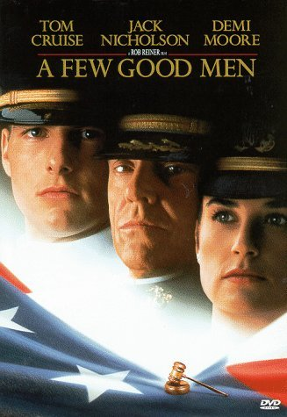
Son, we live in a world that has walls, and those walls have to be guarded by men with guns. Who's gonna do it? You? You, Lt. Weinburg? I have a greater responsibility than you could possibly fathom. You weep for Santiago, and you curse the Marines. You have that luxury. You have the luxury of not knowing what I know. That Santiago's death, while tragic, probably saved lives. And my existence, while grotesque and incomprehensible to you, saves lives. You don't want the truth because deep down in places you don't talk about at parties, you want me on that wall, you need me on that wall. We use words like honor, code, loyalty. We use these words as the backbone of a life spent defending something. You use them as a punchline. I have neither the time nor the inclination to explain myself to a man who rises and sleeps under the blanket of the very freedom that I provide, and then questions the manner in which I provide it. I would rather you just said thank you, and went on your way, Otherwise, I suggest you pick up a weapon, and stand a post. Either way, I don't give a damn what you think you are entitled to.

from the movie “Clueless” (1995) Cher, a high school popularity queen, debates whether all oppressed people should be allowed refuge in America. What tactics does she use? Provide evidence from the text.
So like, right now for example. The Haitians need to come to America. But some people are all, "What about the strain on our resources?" Well it's like when I had this garden party for my father's birthday, right? I put R.S.V.P. 'cause it was a sit-down dinner. But some people came that like did not R.S.V.P. I was like totally buggin'. I had to haul ass to the kitchen, redistribute the food, and squish in extra place settings. But by the end of the day it was, like, the more the merrier. And so if the government could just get to the kitchen, rearrange some things, we could certainly party with the Haitians. And in conclusion may I please remind you it does not say R.S.V.P. on the Statue of Liberty. Thank you very much.
from the Film “Miracle” (2004) Based on a true story. A college coach Herb Brooks is hired to helm the 1980 U.S. men's Olympic hockey team, and he assembles a team of hot-headed college all-stars, who are humiliated in an early match. The U.S. squad tries to overcome insurmountable odds and win the gold medal during the height of the Cold War. What is his tone, purpose, and tactics? Provide evidence from the text.
Great moments... are born from great opportunity. And that's what you have here, tonight, boys. That's what you've earned here tonight. One game. If we played 'em ten times, they might win nine. But not this game. Not tonight. Tonight, we skate with them. Tonight, we stay with them. And we shut them down because we can! Tonight, WE are the greatest hockey team in the world. You were born to be hockey players. Every one of you. And you were meant to be here tonight. This is your time. Their time is done. It's over. I'm sick and tired of hearing about what a great hockey team the Soviets have. Screw 'em. This is your time. Now go out there and take it.

