Review 1 Name: _______________________________ Hr: ______

Gravity' Captures 'Visceral' Nature of Spacewalks, Former Astronaut Says
By Miriam Kramer, Staff Writer | February 28, 2014 07:26am ET

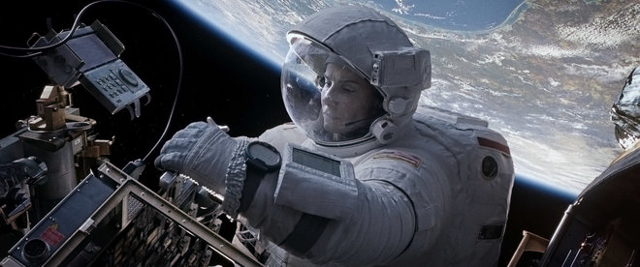

A scene from Warner Bros. Pictures' science-fiction thriller "Gravity," a Warner Bros. Pictures 2013 release.
Credit: Warner Bros. Pictures
The movie "Gravity" recreates the spacewalk experience, according to one former NASA astronaut.
Leroy Chiao, a former commander of the International Space Station, thinks that the fictional space thriller "Gravity," which recently pulled in 10 Oscar nominations, captures what it's like to float through the vacuum of space.
"What I really liked about 'Gravity' is that it created the right look and feel of being in space and doing a spacewalk," Chiao told Space.com. "At times, it did remind me or it made me think about my own experiences in a spacesuit. It also taps into that visceral awareness that the worst thing that can happen to you out there is to become detached and thrown off structure by some accident and be tumbling off into space." [See photos from the movie 'Gravity']
"Gravity," set in the not-too-distant future, tells the story of two astronauts fighting to survive after fast-moving space junk destroys their space shuttle. The astronauts (played by Sandra Bullock and George Clooney) make their way toward the International Space Station in an attempt to survive.
While Leroy Chiao didn't experience anything like the harrowing journey depicted in "Gravity," he still remembers unsettling moments during his spacewalks. The former astronaut remembers floating outside the station during one excursion when he saw that his feet were pointed "downward" toward Earth.
"It was as if I was hanging off a balcony or something," Chiao said. "When I looked down at the Earth, I was able to convince myself that if I let go, I was going to fall. Of course, that wouldn't have happened, but I got that momentary feeling of looking over a bridge or looking over a tall building or something like that where your stomach comes up into your throat."
Other former astronauts, like NASA's Tom Jones, have echoed Chiao's opinions, saying that they too felt that "Gravity" accurately replicates what looking down on the Earth during a spacewalk can feel like.
Films like "Gravity" also go a long way in helping spread the word about NASA missions, Chiao said.
"It's interesting that the pop culture of space travel and space exploration, a lot of people are really into it," Chiao said. "But these same people don't seem to know a lot about the actual space program going on. Certainly more-contemporary type movies like 'Gravity' — which are more or less set in this time frame — help to, generally, build awareness for space exploration. I view that as a positive."

Movies capture the imagination, Chiao said, partially because they have long-running and high-profile promotional campaigns, unlike scientific studies. "Most people, when they're hit with it [news about real space missions], they like it, but they don't have enough time or just raw interest to go out looking for that kind of news."
"Gravity" is nominated for 10 Academy Awards including best picture and best director. The 2014 Academy Awards will air March 2 at 7 p.m. EST (0000 March 3 GMT) on ABC.
Follow Miriam Kramer @mirikramer and Google+. Follow us @Spacedotcom, Facebook and Google+. Original article on Space.com.

Review 2

'Gravity' Is A Game-Changing Masterpiece
Mark Hughes , CONTRIBUTOR
I write about films, especially superhero films, & Hollywood. Opinions expressed by Forbes Contributors are their own.
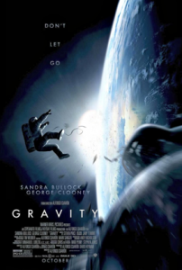
Ladies and gentlemen, we have a game-changer. Aside from everything else that can be said to praise the new Warner Bros.sci-fi thriller Gravity, the first thing that you should know is, you've never seen anything like the visual experience of this film. It's akin to the effects leaps represented by 2001: A Space Odyssey, Star Wars, and Avatar. So realistic and breathtaking, in fact, that you'll forget you're watching special effects, and feel as if the movie were actually shot in space. But as great as that is, there's far more to praise about director Alfonso Cuarón's masterpiece than just the greatest special effects to yet grace the big screen.
With a modest $80 million price tag (a surprising figure, because the film looks better than most movies with budgets twice or three times that amount), it should be easy for Gravity to get into the black. It faces little competition on opening weekend, and good word of mouth should help it pick up additional viewership in subsequent weeks.
The film should also be helped by the strong Oscar buzz for director Cuarón, for stars Sandra Bullock and George Clooney, for the visual effects, for the cinematography, for the sound editing, for the film editing, and for the overall movie itself. I think it's likely to get nods in most of those categories, and should be a lock to win the award for visual effects and sound editing.
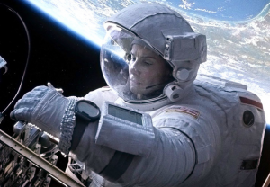
Gravity is one of the finest portrayals of space travel in cinema history. The level of technical detail and accuracy is amazing, and Cuarón's use of extended sequences without cuts magnificently enhances the sense of place and realism. If you've seen the IMAX film Hubble 3D, you might have some idea of what to expect with Gravity. The audience experiences the weightlessness and vast distances in space in a way no other film has accomplished before, and the intensity of the experience for the audience causes a greater sense of connection to the characters as they endure one crisis after another. As Bullock gasps for breath and desperately cries for help as she spins uncontrollably away from the shuttle and other astronauts, we move closer toward her until we're actually inside her helmet with her, watching her oxygen levels drop lower and lower.
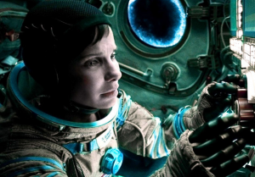
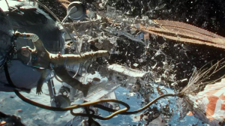
Much will be said about the visual effects, and rightly so. However, Gravity deserves equal praise for its brilliant use of sound and silence. There are moments of mass destruction in orbit that unfold silently, except for the breath or voice of the characters and the score. Most of the film lacks much in the way of ambient sound, by nature of the environment, so it's important that the filmmakers put as much attention into getting the sound right as they did the perfect visuals. And I cannot imagine the immensity of the work and precision involved in the film editing on this project. On every technical level, it is simply amazing and represents a huge leap forward for visual effects. In the coming years, it will be interesting to see this level of realism applied to other films (as a huge fan of the superhero genre, I salivate at the prospect of such effects work in future comic book adaptations).
But one of the best things about Gravity is that its success isn't just in the technical realms, but also in storytelling and character. The concept itself is simple enough -- astronauts on a routine mission who end up stranded in orbit and must fight for survival. But upon that foundation is built a powerful character arc, given life by Sandra Bullock in a performance that is sure to earn her a second Oscar nomination.
It's a carefully crafted emotional journey for a woman whose life has (due to a tragedy in her past) lost purpose or feeling beyond her work, who isolates and insulates herself from other people, and who must confront her loss and fear and regain a desire to live rather than just exist. Her arc is -- like the survival story itself -- straightforward and not driven by particularly complicated plotting, but rather is driven by great emotional complexity and atmosphere (pardon the expression).
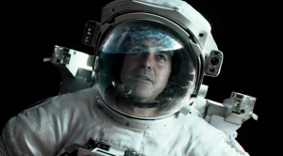
George Clooney's supporting performance takes his usual easy charm and turns it into an important component of the fight to stay alive. With Bullock's novice consumed by fear and the situation around them so precarious, Clooney's veteran astronaut must break through Bullock's emotional wall and convince her of his faith in her inner strength to not only overcome this crisis that's left her drifting in space, but also overcome her inner crisis that left her drifting through her personal life.
Alfonso Cuarón's previous film, the acclaimed Children of Men, demonstrated such virtuosity that we all wondered whether he could top it. With Gravity, we have our answer, and it's a resounding "yes."
You don't have to love sci-fi to love Gravity, you just have to love the power of cinema to provide a transcendent experience.
Task
- Identify the elements that each author (Kramer and Hughes) chooses to review about the film.
Review 1 Criticisms by Miriam Kramer | Review 2 Critcisms by Mark Hughes

- Identify the author’s purpose with each article. How are they similar? How are they different?
_________________________________________________________________________________________________________________________________________________________________________________________________________________________________________________________________________________________________________________________________________________________________________________________________________________________________________________________________________________________________________________________________________________________________________________________________________________________________________________________________________________________________________________________________________________________________________________________________________________________________
Which criticism/review do you think is more effective and why? Support your claim with evidence. _____________________________________________________________________________________________________________________________________________________________________________________________________________________________________________________________________________________________________________________________________________________________________________________________________________________________________________________________________________________________________________________________________________________________________________________________________________________________________________________________________________________________________________________________________________________________________________________________________________________________________________________________________________________________________________________________________________________________________________________________________________________________________________________________________________________________________________________________________________________________________________________________________

